Getting started
- You will need Visual Studio Code. This is an absolutely excellent free software editor from Microsoft. It is kind of a less heavy brother to Visual Studio, which also has a free version. If we do another project later, we may use that too but for now this is more than good enough. Install the Windows / Linux / Mac version for whatever computer you have. https://code.visualstudio.com/download
- Install Git. The default settings for the installer should work fine. This is source control. You will be checking in your code as you complete things, and I can check it out on my end. Everybody uses Git now, and it's a great way to share code. This will be something you can put on your resume.
https://git-scm.com/downloads
- Create a directory/folder on your computer. I recommend c:\source if you are using Windows, or perhaps c:\users\<your user name>\source if you want it be part of your user folder.
- Clone the repository at github
- Open the project by opening the workspace file. It should come up automatically in Visual Studio Code if it is installed correctly.
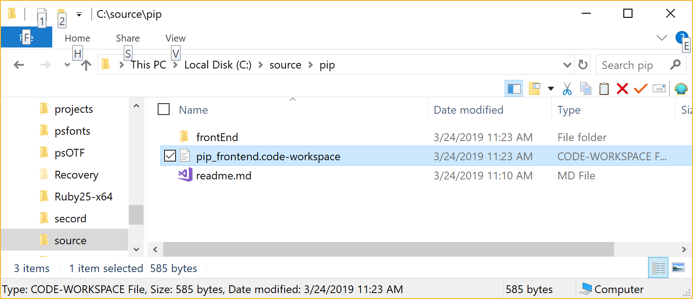
- You will need to install an extension to get SASS files to compile. Click on the Extension Manager as shown here:
- Search for Live Sass Compiler, click on the listing, then click on either of the green Install buttons.
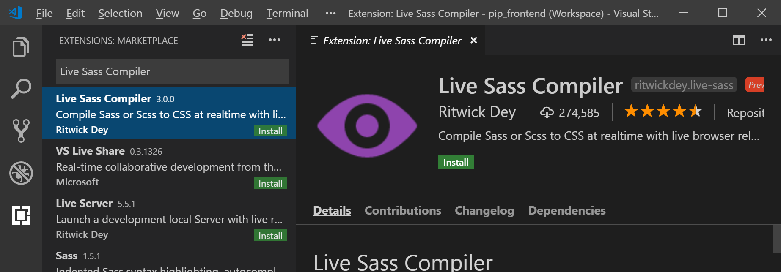
- It will take a moment or two to run after it installs. You may also have to click on the folder icon on the top right, open up the scss folder and click on the styles.scss file to activate it. You will eventually see a little icon that looks like an eye labeled "Watch Sass" in the tray of Visual Studio Code:
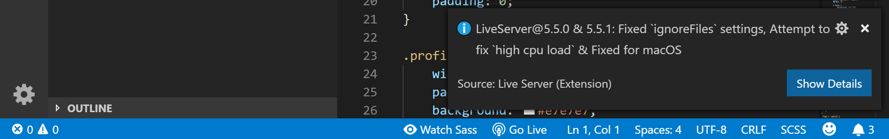
- It will generate several folders and files. You are now ready to write code.
- Open up the file profile.html in the editor. If you right click near the tab, it will pop up a option list. Click Reveal in Explorer. If you are on a Mac it might say something a little different, like Finder.
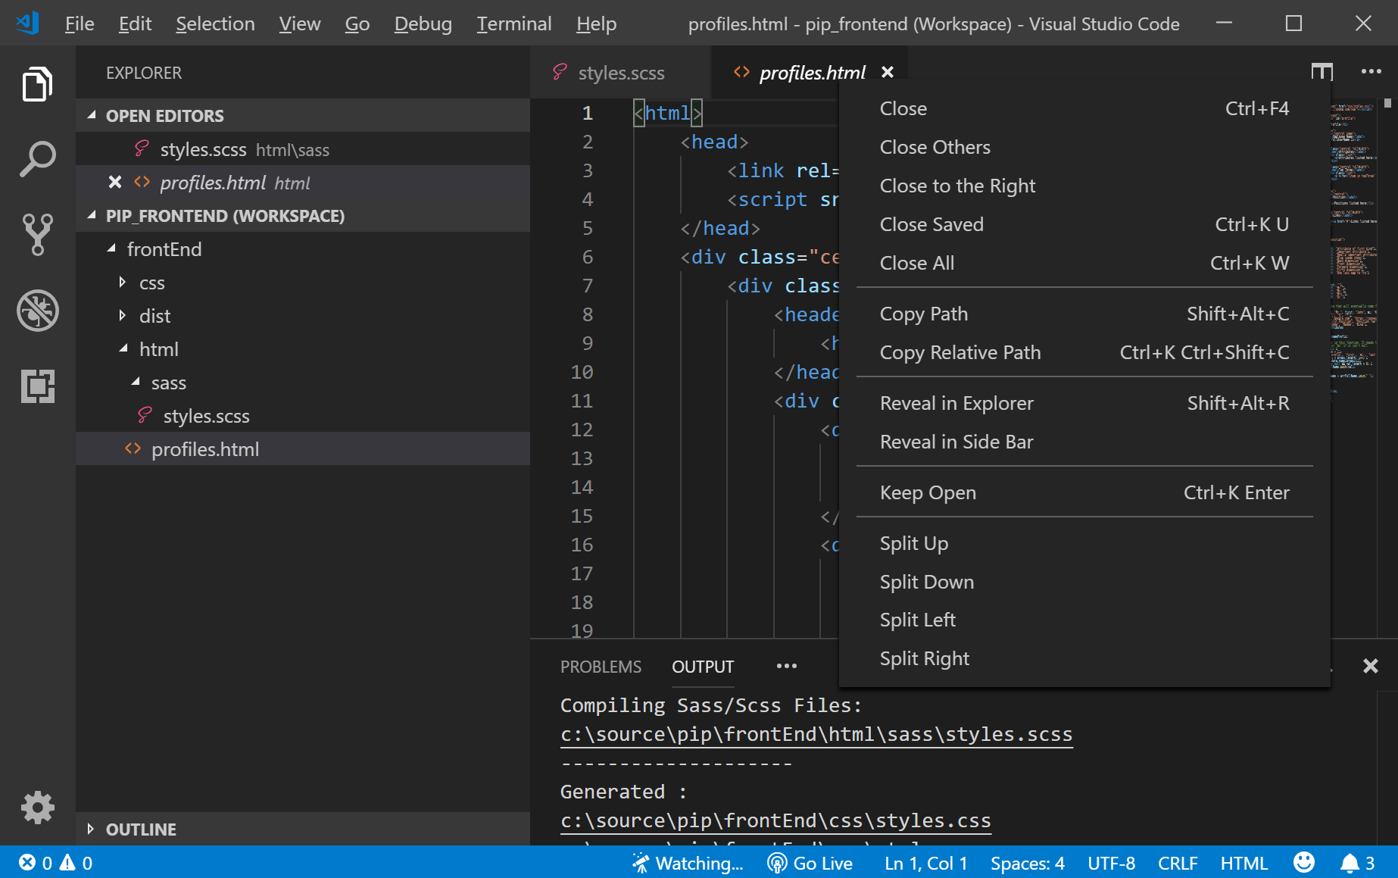

Your First Task
Edit the styles.scss file to create the necessary .css to make the page look as much like this as you can. If you email me or text me with questions, I can answer them, but the best thing you can do is try to search with Google to try to answer them yourself.
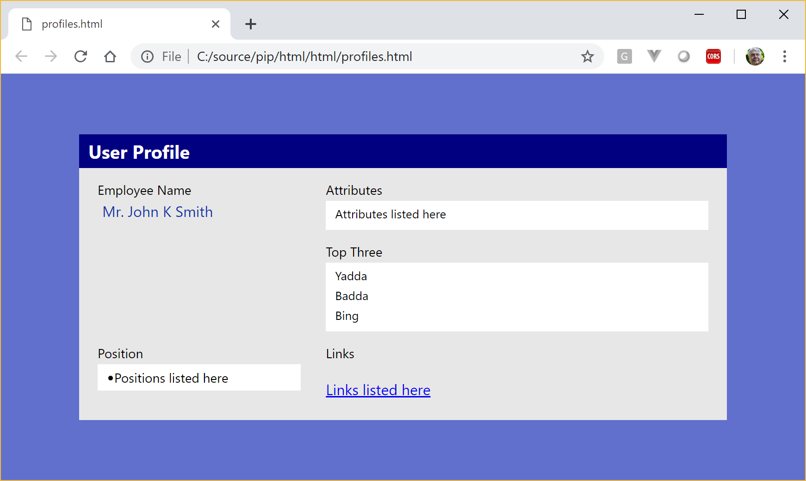
I can give you a hint that flex layout is going to be the right way to make the box centered in the page using the "centeredLayout" tag. I already have the class names in place in the html, and I know they are sufficient since I just removed the styles from the .scss file, I didn't change the html.
BTW, there is a background I've left as a SASS variable, so the whitish areas behind the blocks can be styled using it such as background: $boxBackground. You may want to do this with all the colors and perhaps even some of the common spacing in the .scss. SASS has some even kewler features that we will later explore such as plugIns, and you can do some amazing things with them.
If you get that done and have time, you can learn how to do the markup for VueJS that I have deleted out of the other code. I have left two things already setup in the html.
Sass makes it easier to do CSS, because you can nest things that are related to each other together. For example, I've left nesting of elements in place where I could in the .scss.
In css you have to write a separate line for each path to an object (which is called it's specificity, BTW, if you are answering interview questions).
So the following .scss in the exercise looks like the left side below, but the rendered .css looks like the right side.
.profile {  width: 700px;  padding: 0 0 7px 0;  background: #e7e7e7;  > header {  width: calc(100% - 20px);  padding: 5px 10px;  }  > .row {  > .name {  > p {  margin: 0 0 0 5px;  color: #1133AA;  }  }  }  } |  | .profile {  width: 700px;  padding: 0 0 7px 0;  background: #e7e7e7;  }  .profile > header {  width: calc(100% - 20px);  padding: 5px 10px;  }  .profile > .row > .name > p {  margin: 0 0 0 5px;  color: #1133AA;  }
The .css code is simpler, but it is really hard to maintain. If you decide to change how the .css is nested, you must find all of the lines and change them.
In the code above, the > brackets mean a style tag that is a direct child of the outer tag. If you leave the bracket off such as .profile header instead of .profile > header, the any element tagged with that style inside the outer tag will have the properties you assign it.
The .dot before a tag name indicates that it is a class. If it has no prefix at all, it is an html element. You can also use Ids using #thisIsAnId to prefix the name, but it is bad practice IMHO. I only use class names, so that you don't have to search for both Ids AND class names to find out why something is behaving some way.
To get things to align left and right in the rows, you are going to have to use float: left and/or float: right, or use flex. I think I used flex because then I can have it automatically calculate spacing of the columns.
I will answer questions when I get stuck, but you get way extra learning if you can figure out how to find the answers yourself.
For example, on flex, search for .css flex center an element. You will get a lot of links. At least one of them will have a good example.

